30.72: a) Immediately after is closed, the inductor maintains the current 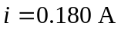 through 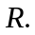 The Kirchoff’s Rules around the outside of the circuit yield:
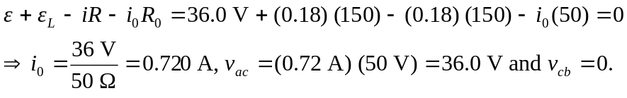
b) After a long time, 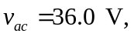 and 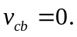 Thus
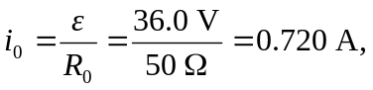
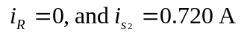
c) 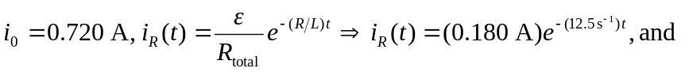
Below are the graphs of currents found above.

